Traffic Signal Optimization
Team members:
2520030587-Sai Spoorthi
2520030586-Hamsika
2520030591-Sudeshna
Abstract
Traffic congestion at intersections increases waiting time, fuel consumption, and pollution because traditional traffic signals use fixed timing cycles. Our project proposes a Rule-Based Traffic Signal Optimization System that adjusts traffic signals based on real-time conditions such as vehicle density, waiting time, emergency vehicle detection, and pedestrian requests.
The system uses predefined IF–THEN rules to dynamically control signal timings. Roads with heavy traffic or long waiting queues receive longer green signals, while emergency vehicles are given immediate priority. This approach improves traffic flow, reduces congestion and fuel wastage, and prevents lane starvation.
Unlike machine learning systems, the proposed method is simple, cost-effective, and easy to implement, making it suitable for real-time smart traffic management applications. The system includes a graphical dashboard that displays traffic analysis, image-based density estimation, AI reasoning, signal optimization decisions, and traffic reports.
Problem Statement
Conventional traffic signal systems operate with fixed timing cycles regardless of traffic conditions. This leads to unnecessary waiting time, traffic congestion, fuel wastage, pollution, and delayed emergency vehicle movement. Therefore, there is a need for a smart traffic management system that can dynamically adjust signal timings based on real-time traffic conditions using simple rule-based logic.
Solution
The proposed solution is a Rule-Based Smart Traffic Signal Optimization System developed using Python, Tkinter, and OpenCV. The system allows users to select traffic scenarios through images representing different traffic conditions. OpenCV-based image processing is used to estimate traffic density from the selected image. The system also uses traffic parameters such as vehicle count, sensor readings, and waiting time.
A Priority Score is calculated using vehicle count and waiting time. Based on predefined IF–THEN rules, the system determines the optimal green signal duration. Emergency vehicles receive immediate priority through an override mechanism. The system displays traffic analysis, AI reasoning, optimization measures, and generates traffic reports for monitoring and performance evaluation.

Plan of Action
Module | Description
Traffic Scenario Selection & Data Collection Module | Uses traffic scenario images and OpenCV-based image processing to estimate traffic density. The module retrieves traffic parameters such as vehicle count, waiting time, sensor readings, and emergency vehicle status for further analysis.
Rule-Based AI Decision & Signal Optimization Module | Calculates Priority Score using traffic parameters and applies IF–THEN rules to determine lane priority and green signal duration. Emergency vehicles receive immediate signal priority.
Traffic Analysis Dashboard & Report Generation Module | Displays traffic status, selected scenario, AI reasoning, optimization measures, signal timing decisions, and generates traffic reports for monitoring and performance evaluation.

Algorithm
Step 1: User selects a traffic scenario.
Step 2: System retrieves vehicle count, sensor readings, and waiting time.
Step 3: Calculate Priority Score.
Priority Score = (Vehicle Count × 2) + Waiting Time
Step 4: Apply Rule-Based AI.
IF Emergency Vehicle Detected
Green Signal = 60 Seconds
ELSE IF Priority Score > 120
Green Signal = 60 Seconds
ELSE IF Priority Score > 60
Green Signal = 40 Seconds
ELSE
Green Signal = 20 Seconds
Step 5: Display traffic analysis, optimization measures, and AI reasoning.
Step 6: Generate traffic report.

CO’s Attainnments
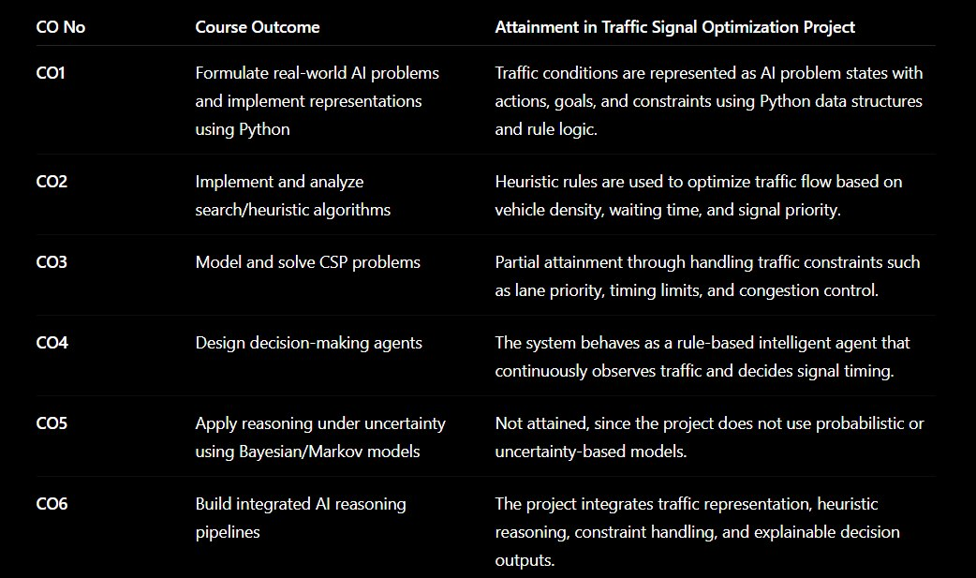

CODE
from tkinter import *
from PIL import Image, ImageTk
import os
# =====================================================
# WINDOW
# =====================================================
root = Tk()
root.title("Smart Traffic Signal Optimization System")
root.state("zoomed")
root.configure(bg="white")
BASE_DIR = os.path.dirname(os.path.abspath(__file__))
# =====================================================
# DATA
# =====================================================
TRAFFIC_DATA = {
"High Traffic": {
"vehicles": 57,
"sensor": 52,
"waiting": 31,
"signal": 60,
"efficiency": 92,
"status": "🔴 HIGH TRAFFIC",
"reason":
"""
• Heavy congestion detected
• Vehicle density above threshold
• Priority score highest
• Signal duration increased
""",
"measures":
"""
✓ Green Signal Extended

✓ Congestion Reduction Activated

✓ Lane Priority Increased

✓ Traffic Monitoring Enabled
"""
},
"Medium Traffic": {
"vehicles": 34,
"sensor": 30,
"waiting": 18,
"signal": 40,
"efficiency": 88,
"status": "🟡 MEDIUM TRAFFIC",
"reason":
"""
• Moderate traffic detected
• Normal optimization applied
• Traffic flow balanced
""",
"measures":
"""
✓ Balanced Traffic Flow

✓ Standard Optimization

✓ Dynamic Monitoring
"""
},
"Low Traffic": {
"vehicles": 12,
"sensor": 10,
"waiting": 8,
"signal": 20,
"efficiency": 96,
"status": "🟢 LOW TRAFFIC",
"reason":
"""
• Low vehicle density
• No congestion detected
• Standard timing sufficient
""",
"measures":
"""
✓ Standard Signal Timing

✓ Smooth Traffic Flow
"""
},
"Emergency Vehicle": {
"vehicles": 25,
"sensor": 22,
"waiting": 5,
"signal": 60,
"efficiency": 100,
"status": "🚑 EMERGENCY PRIORITY",
"reason":
"""
• Ambulance detected
• Priority override activated
• Fastest route selected
""",
"measures":
"""
✓ Immediate Green Signal

✓ Route Clearance

✓ Other Lanes Temporarily Stopped

✓ Emergency Priority Mode
"""
}
}
# =====================================================
# VARIABLES
# =====================================================
status_var = StringVar()
status_var.set("⚪ Waiting For Analysis")
selected_img_label = None
# =====================================================
# FUNCTIONS
# =====================================================
def generate_report():
report = dashboard_text.get("1.0", END)
with open("traffic_report.txt", "w") as file:
file.write(report)
status_var.set("✅ Report Generated")
def analyze(scenario, image_path):
data = TRAFFIC_DATA[scenario]
vehicles = data["vehicles"]
sensor = data["sensor"]
waiting = data["waiting"]
# =================================================
# AI PRIORITY SCORE CALCULATION
# =================================================
priority_score = (vehicles * 2) + waiting
# =================================================
# RULE-BASED AI DECISION ENGINE
# =================================================
if scenario == "Emergency Vehicle":
signal_time = 60
applied_rule = """
Emergency Vehicle Detected
Priority Override Activated

Immediate Green Signal Assigned
"""
elif priority_score > 120:
signal_time = 60
applied_rule = """
Priority Score > 120
Heavy Congestion Detected
Green Signal Extended To 60 Seconds
"""
elif priority_score > 60:
signal_time = 40
applied_rule = """
Priority Score > 60
Moderate Traffic Detected
Green Signal Set To 40 Seconds
"""
else:
signal_time = 20
applied_rule = """
Priority Score <= 60
Low Traffic Detected
Standard Signal Time Applied
"""
status_var.set(data["status"])
# =================================================
# DASHBOARD UPDATE
# =================================================

dashboard_text.delete("1.0", END)
dashboard_text.insert(
END,
f"""
TRAFFIC ANALYSIS REPORT
==================================================
Traffic Type : {scenario}
Vehicle Count : {vehicles}
Sensor Reading : {sensor}
Waiting Time : {waiting} sec
Priority Score : {priority_score}
Green Signal Duration : {signal_time} sec
Optimization Efficiency : {data['efficiency']} %
==================================================
MEASURES TAKEN
{data['measures']}
==================================================
AI REASONING
{data['reason']}
==================================================
DECISION LOGIC
Priority Score Formula
Priority Score
= (Vehicle Count × 2) + Waiting Time
= ({vehicles} × 2) + {waiting}
= {priority_score}
==================================================
RULE APPLIED
{applied_rule}
==================================================
"""
)
# =================================================
# IMAGE UPDATE
# =================================================
image = Image.open(image_path)
image = image.resize((350, 250))
photo = ImageTk.PhotoImage(image)
selected_img_label.config(image=photo)
selected_img_label.image = photo
# =====================================================
# TITLE
# =====================================================
Label(
root,
text="SMART TRAFFIC SIGNAL OPTIMIZATION SYSTEM",
font=("Arial", 22, "bold"),
bg="white",
fg="darkblue"
).pack(pady=15)
# =====================================================
# MAIN CONTAINER
# =====================================================
main_frame = Frame(root, bg="white")
main_frame.pack(fill=BOTH, expand=True)

# =====================================================
# LEFT PANEL
# =====================================================
left_panel = Frame(
main_frame,
bg="white",
width=500
)
left_panel.pack(
side=LEFT,
fill=Y,
padx=20
)
# =====================================================
# RIGHT PANEL
# =====================================================
right_panel = Frame(
main_frame,
bg="white"
)
right_panel.pack(
side=RIGHT,
fill=BOTH,
expand=True,
padx=20
)
# =====================================================
# LOAD IMAGES
# =====================================================
high_path = os.path.join(BASE_DIR, "high_traffic.jpg")
medium_path = os.path.join(BASE_DIR, "medium_traffic.jpg")
low_path = os.path.join(BASE_DIR, "low_traffic.jpg")
emergency_path = os.path.join(BASE_DIR, "emergency.jpg")
def create_thumb(path):
img = Image.open(path)
img = img.resize((160, 90))
return ImageTk.PhotoImage(img)
high_img = create_thumb(high_path)
medium_img = create_thumb(medium_path)
low_img = create_thumb(low_path)
emergency_img = create_thumb(emergency_path)
# =====================================================
# LEFT SIDE IMAGES
# =====================================================
Label(
left_panel,
text="Traffic Scenarios",
font=("Arial", 16, "bold"),
bg="white"
).pack(pady=10)
for title, image, path in [
("High Traffic", high_img, high_path),
("Medium Traffic", medium_img, medium_path),
("Low Traffic", low_img, low_path),
("Emergency Vehicle", emergency_img, emergency_path)
]:
frame = Frame(left_panel, bg="white")
frame.pack(pady=5)
Label(
frame,
image=image,
bg="white"
).pack()
Button(
frame,
text=title,
width=25,
command=lambda t=title,p=path:
analyze(t,p)
).pack(pady=5)
# =====================================================
# STATUS
# =====================================================
Label(
right_panel,
textvariable=status_var,
font=("Arial",16,"bold"),
bg="white"
).pack(pady=10)
# =====================================================
# SELECTED IMAGE
# =====================================================

selected_frame = LabelFrame(
right_panel,
text="Selected Scenario",
bg="white",
font=("Arial",12,"bold")
)
selected_frame.pack(fill=X)
selected_img_label = Label(
selected_frame,
bg="white"
)
selected_img_label.pack(pady=10)
# =====================================================
# DASHBOARD
# =====================================================
dashboard_frame = LabelFrame(
right_panel,
text="Traffic Analysis Dashboard",
bg="white",
font=("Arial",12,"bold")
)
dashboard_frame.pack(
fill=BOTH,
expand=True,
pady=15
)

dashboard_text = Text(
dashboard_frame,
font=("Consolas",11),
wrap=WORD
)
dashboard_text.pack(
fill=BOTH,
expand=True
)
dashboard_text.insert(
END,
"Select a traffic scenario to begin analysis."
)
# =====================================================
# REPORT BUTTON
# =====================================================
Button(
right_panel,
text="Generate Traffic Report",
bg="darkgreen",
fg="white",
font=("Arial",12,"bold"),
command=generate_report
).pack(pady=10)
root.mainloop()

OUTPUT:
For High Traffic
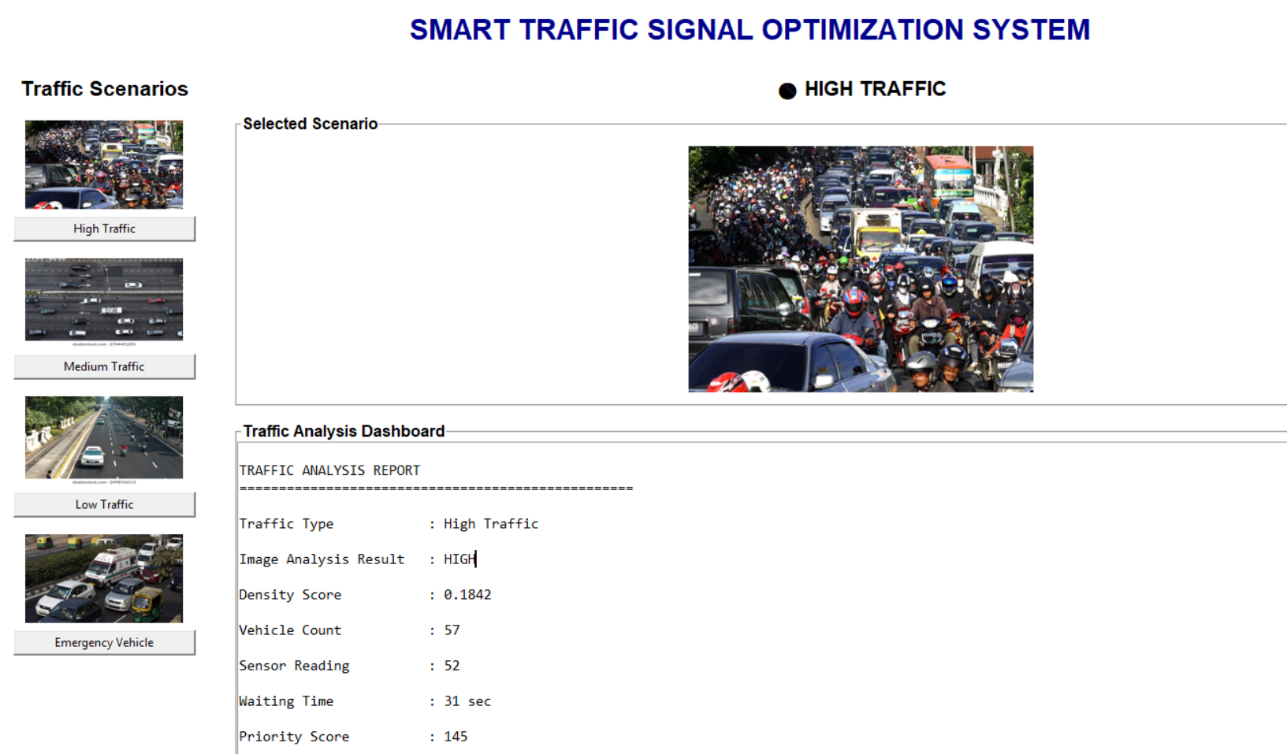
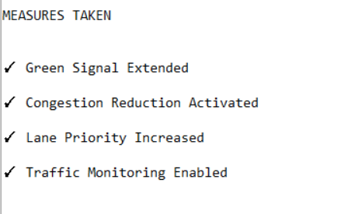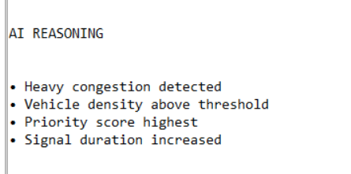
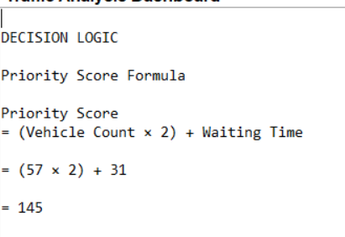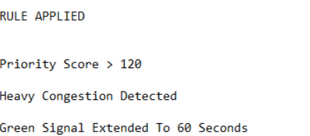

For Emergency Vehicle
